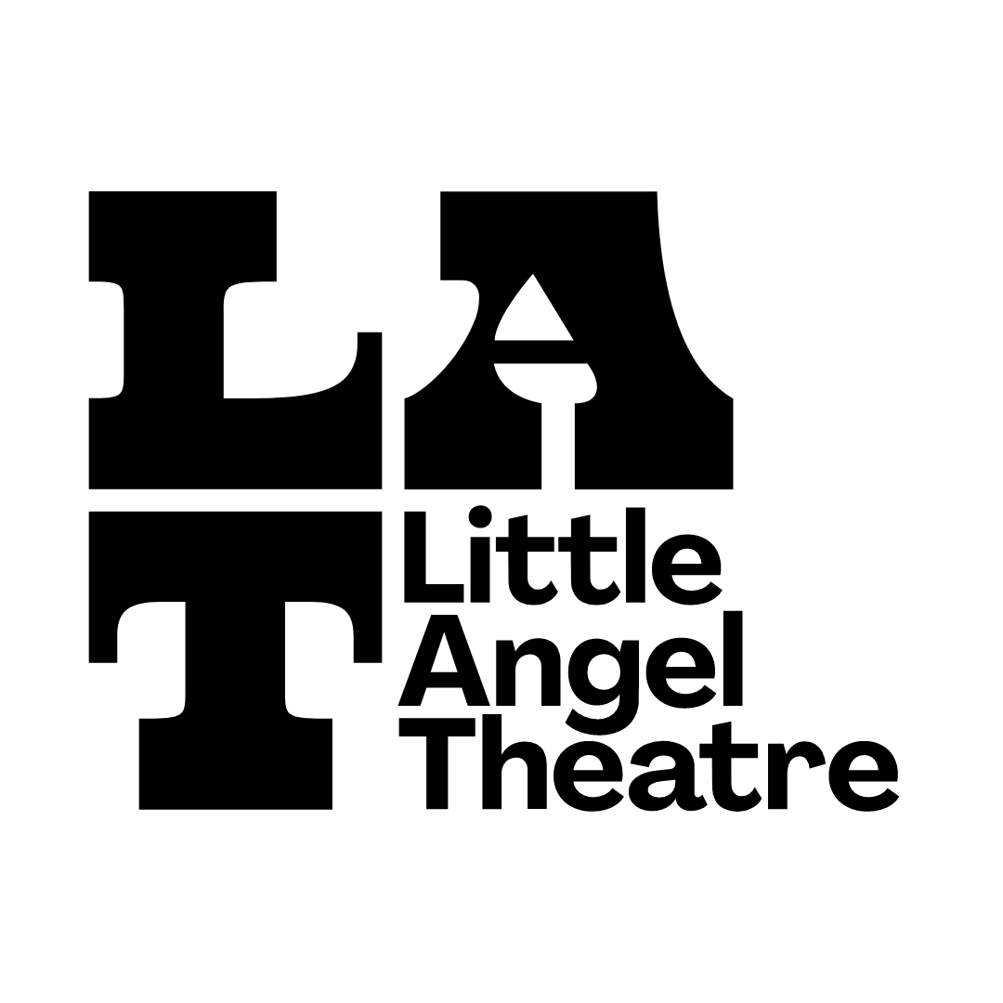

Legacy Pledge Form
Please note that this pledge is strictly confidential and is in no way legally binding.

Title
First name
Last name/Surname
Address
Postcode
Telephone no.
Email

Your gift
◻ I am intending to include Little Angel Theatre in my Will.
◻ I have already included Little Angel Theatre in my Will.

Designating your gift
Please let us know if you are happy for your gift to be used wherever the need is greatest
YES/NO

If you would prefer your gift to be used for a specific purpose please tell us here:
◻Little Angel Theatre productions
◻ Little Angel Theatre’s Creative learning programmes
◻ Little Angel Theatre’s cherished building
◻ Little Angel Theatre’s Community engagement programme

If you have already included a gift in your Will to Little Angel Theatre, or intend to in the future, we would very much like to hear your story. This will help us understand why people choose to support our work in this way. However, please note that this information is not binding in any way and without your permission will be treated with the utmost confidence.

I am leaving a legacy to the Little Angel Theatre because:

◻ I would be happy for Little Angel Theatre to share my story with other supporters.

Please return this form to development@littleangeltheatre.com. Tel: 020 8545 8353. Little Angel Theatre is a registered charity number 232488.

