Visitor Experience Assistant
Recruitment Pack

Photo credit Suzi Corker

Overview

Job title: Visitor Experience Assistant

Reports to: Visitor Experience and Operations Manager

Pay: We pay above the London Living Wage - £11.18, plus holiday pay

Hours: This is a casual, zero hours role. Shifts vary in length. Our core shift patterns are Thursday – Sunday.

About Little Angel Theatre

Little Angel Theatre is a home for puppetry. Since its doors first opened in 1961 the theatre has been dedicated to creating and sharing inspiring stories. Puppetry is at the heart of this innovative theatre, from igniting the imaginations of the youngest minds to equipping tomorrow’s puppeteers with the tools they need to succeed. As well as an internationally recognised theatre with productions touring throughout the UK and across the globe, Little Angel Theatre also has its roots in Islington, and works with its local, diverse community to break down barriers to arts engagement so all can benefit and enjoy this remarkable art form.

“Little Angel is nothing less than an icon of north London childhood.”
Time Out, 2016

For more information about Little Angel Theatre please see www.littleangeltheatre.com

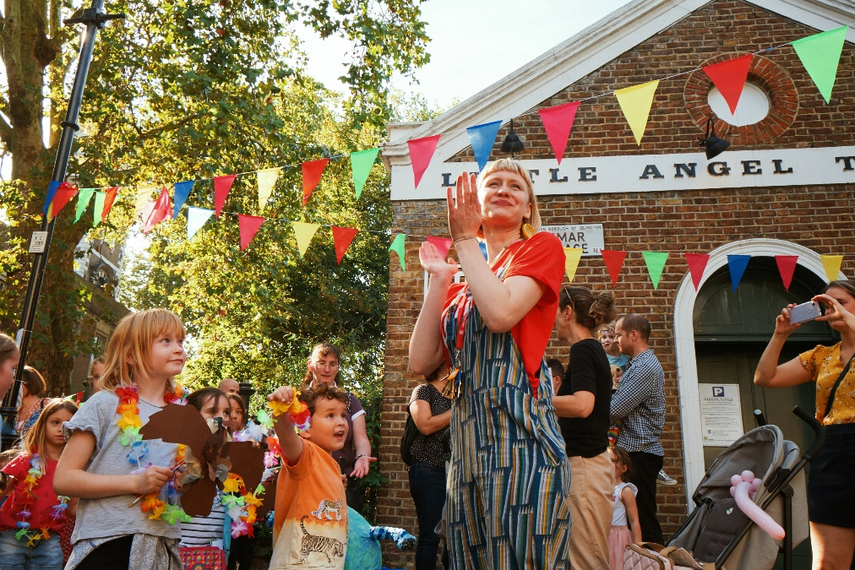

Core Duties

The Role

We are looking for candidates who will bring energy and enthusiasm to every single shift. We are particularly interested in those candidates with experience of working with young audiences and those who have an interest in puppetry or children’s theatre.

No experience is required, training will be offered for the role. This is a casual zero hours role that offers flexibility around your other commitments, however our core shift patterns are Thursday-Sunday. The pay rate is £11.18 per hour (London Living Wage), plus holiday pay. Shifts vary in length.

Duties and responsibilities

- Be friendly, approachable and enthusiastic.
- Deliver a unique LAT Welcome to provide a memorable experience for our audiences.
- Ensure that audiences are seated appropriately – it is a unique challenge in our theatre to make sure all children can see due to the unreserved seating arrangement.
- Attend to the audience to minimize disruption during the show.
- Ensure that the Front of House provides a welcoming atmosphere to all who use it, providing personal greetings to all audience members and providing an introduction to the theatre for first time attendees.
- Undertake other duties as directed to provide a pleasant experience for customers, including cleaning in the building and restocking merchandise.
- Follow all health and safety, fire, and child protection regulations as stipulated.
- Communicate with stage managers and box office to ensure smooth operation of shows.
- Manage evacuation of the theatre in emergencies.
- Assist in ensuring the venue is safe and clean for all those who use it.
- Be a hub of information for audiences, providing details on current and future shows and other workshops and activities offered by Little Angel Theatre.

Applications

The deadline for applications is: 10am, Monday 13th March 2023

Interviews will be held on: Week commencing Monday 20th March.

Start date: As soon as possible

To apply please send a completed Application form and Equal Opportunities form (can be found on our website) to recruitment@littleangeltheatre.com Please quote reference VEA23 in the email subject line.

For more information about the company please see www.littleangeltheatre.com

Little Angel Theatre is an Equal Opportunities and accredited London Living Wage employer.

